**3 Partitions in 1 Topic**

1 Consumer - 3 Partitions

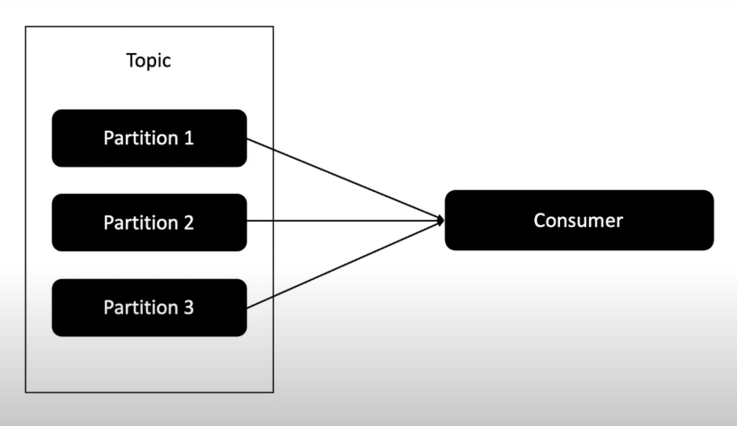

3 Consumers in 1 Consumer Group

1 Consumer - 1 Partition

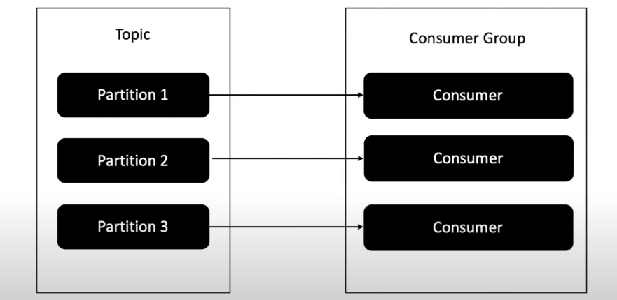

3 Consumers (2 Active, 1 Dead) in 1 Consumer Group

1 Consumer - 1 Partition

1 Consumer - 2 Partitions

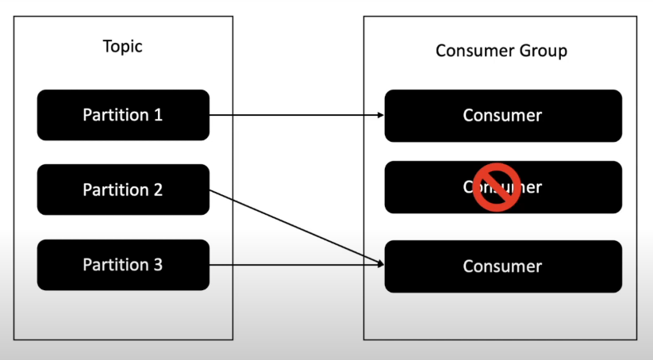

4 Consumers in 1 Consumer Group

1 Consumer - 1 Partition

1 Consumer - Idle

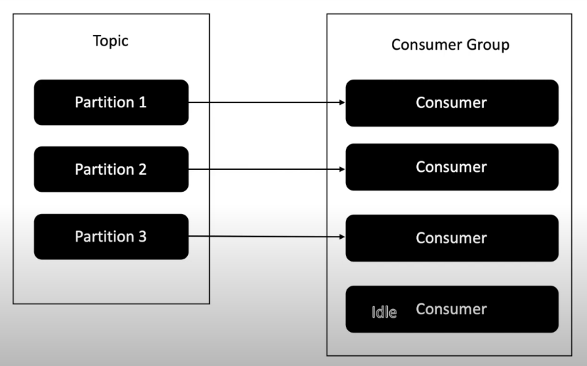

4 Consumers (3 Active, 1 Dead) in 1 Consumer Group

1 Consumer - 1 Partition

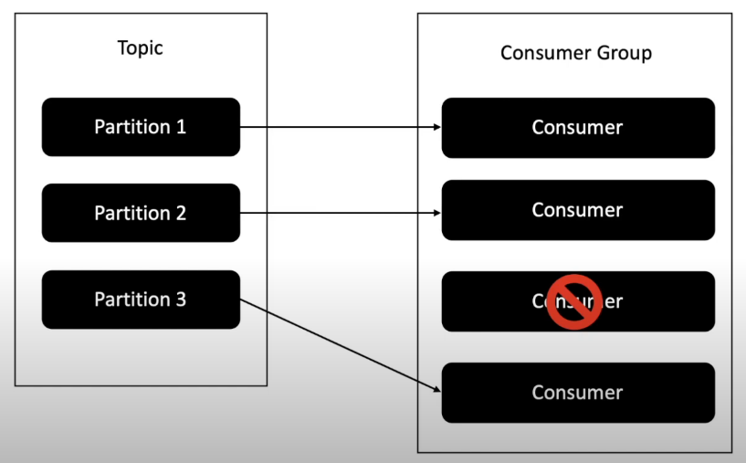

### NO ACTIVE CONSUMERS ###

C:\kafka_2.13-3.1.0\bin\windows>kafka-consumer-groups.bat --bootstrap-server localhost:9092 --group consumer-group-1 --describe

Consumer group 'consumer-group-1' has no active members.

GROUP TOPIC PARTITION CURRENT-OFFSET LOG-END-OFFSET LAG CONSUMER-ID HOST CLIENT-ID

consumer-group-1 poc-test3-3 2 2 2 0 - - -

consumer-group-1 poc-test4-6 4 9 50 41 - - -

consumer-group-1 poc-test4-6 3 31 47 16 - - -

consumer-group-1 poc-test3-3 1 2 2 0 - - -

consumer-group-1 poc-test4-6 0 10 53 43 - - -

consumer-group-1 poc-test4-6 1 12 56 44 - - -

consumer-group-1 poc-test1 0 11 12 1 - - -

consumer-group-1 poc-test4-6 2 18 57 39 - - -

consumer-group-1 poc-test4-6 5 13 51 38 - - -

consumer-group-1 poc-test3-3 0 2 2 0 - - -

### ACTIVE CONSUMERS - 1 ###

### client-2-ea8da305-be00-40bf-94f2-dfc574c9815e | PARTITION 0-5 ###

C:\kafka_2.13-3.1.0\bin\windows>kafka-consumer-groups.bat --bootstrap-server localhost:9092 --group consumer-group-1 --describe | findstr /c:"poc-test4-6"

consumer-group-1 poc-test4-6 4 9 50 41 client-2-ea8da305-be00-40bf-94f2-dfc574c9815e /63.29.200.230 client-2

consumer-group-1 poc-test4-6 2 18 57 39 client-2-ea8da305-be00-40bf-94f2-dfc574c9815e /63.29.200.230 client-2

consumer-group-1 poc-test4-6 3 32 47 15 client-2-ea8da305-be00-40bf-94f2-dfc574c9815e /63.29.200.230 client-2

consumer-group-1 poc-test4-6 0 10 53 43 client-2-ea8da305-be00-40bf-94f2-dfc574c9815e /63.29.200.230 client-2

consumer-group-1 poc-test4-6 5 13 51 38 client-2-ea8da305-be00-40bf-94f2-dfc574c9815e /63.29.200.230 client-2

consumer-group-1 poc-test4-6 1 12 56 44 client-2-ea8da305-be00-40bf-94f2-dfc574c9815e /63.29.200.230 client-2

### ACTIVE CONSUMERS - 2 ###

### client-2-ce34ac16-882d-466a-bc7e-33f437476b47 | PARTITION 0,1,2 ###

### client-2-ea8da305-be00-40bf-94f2-dfc574c9815e | PARTITION 3,4,5 ###

C:\kafka_2.13-3.1.0\bin\windows>kafka-consumer-groups.bat --bootstrap-server localhost:9092 --group consumer-group-1 --describe | findstr /c:"poc-test4-6"

consumer-group-1 poc-test4-6 0 10 53 43 client-2-ce34ac16-882d-466a-bc7e-33f437476b47 /63.29.200.230 client-2

consumer-group-1 poc-test4-6 1 13 56 43 client-2-ce34ac16-882d-466a-bc7e-33f437476b47 /63.29.200.230 client-2

consumer-group-1 poc-test4-6 2 20 57 37 client-2-ce34ac16-882d-466a-bc7e-33f437476b47 /63.29.200.230 client-2

consumer-group-1 poc-test4-6 3 33 47 14 client-2-ea8da305-be00-40bf-94f2-dfc574c9815e /63.29.200.230 client-2

consumer-group-1 poc-test4-6 4 9 50 41 client-2-ea8da305-be00-40bf-94f2-dfc574c9815e /63.29.200.230 client-2

consumer-group-1 poc-test4-6 5 14 51 37 client-2-ea8da305-be00-40bf-94f2-dfc574c9815e /63.29.200.230 client-2

### AUTO REBALANCING ###

C:\kafka_2.13-3.1.0\bin\windows>kafka-consumer-groups.bat --bootstrap-server localhost:9092 --group consumer-group-1 --describe | findstr /c:"poc-test4-6"

Warning: Consumer group 'consumer-group-1' is rebalancing.

consumer-group-1 poc-test4-6 4 11 50 39 - - -

consumer-group-1 poc-test4-6 3 34 47 13 - - -

consumer-group-1 poc-test4-6 0 11 53 42 - - -

consumer-group-1 poc-test4-6 1 14 56 42 - - -

consumer-group-1 poc-test4-6 2 21 57 36 - - -

consumer-group-1 poc-test4-6 5 14 51 37 - - -

### ACTIVE CONSUMERS - 3 ###

### client-2-5c28f056-d4f3-4569-bbd3-94d5e1498cb3 | PARTITION 0,1 ###

### client-2-ce34ac16-882d-466a-bc7e-33f437476b47 | PARTITION 2,3 ###

### client-2-ea8da305-be00-40bf-94f2-dfc574c9815e | PARTITION 4,5 ###

C:\kafka_2.13-3.1.0\bin\windows>kafka-consumer-groups.bat --bootstrap-server localhost:9092 --group consumer-group-1 --describe | findstr /c:"poc-test4-6"

consumer-group-1 poc-test4-6 0 12 53 41 client-2-5c28f056-d4f3-4569-bbd3-94d5e1498cb3 /63.29.200.230 client-2

consumer-group-1 poc-test4-6 1 16 56 40 client-2-5c28f056-d4f3-4569-bbd3-94d5e1498cb3 /63.29.200.230 client-2

consumer-group-1 poc-test4-6 2 22 57 35 client-2-ce34ac16-882d-466a-bc7e-33f437476b47 /63.29.200.230 client-2

consumer-group-1 poc-test4-6 3 36 47 11 client-2-ce34ac16-882d-466a-bc7e-33f437476b47 /63.29.200.230 client-2

consumer-group-1 poc-test4-6 4 12 50 38 client-2-ea8da305-be00-40bf-94f2-dfc574c9815e /63.29.200.230 client-2

consumer-group-1 poc-test4-6 5 16 51 35 client-2-ea8da305-be00-40bf-94f2-dfc574c9815e /63.29.200.230 client-2

### AUTO REBALANCING ###

C:\kafka_2.13-3.1.0\bin\windows>kafka-consumer-groups.bat --bootstrap-server localhost:9092 --group consumer-group-1 --describe | findstr /c:"poc-test4-6"

Warning: Consumer group 'consumer-group-1' is rebalancing.

consumer-group-1 poc-test4-6 4 13 50 37 - - -

consumer-group-1 poc-test4-6 3 37 47 10 - - -

consumer-group-1 poc-test4-6 0 13 53 40 - - -

consumer-group-1 poc-test4-6 1 17 56 39 - - -

consumer-group-1 poc-test4-6 2 23 57 34 - - -

consumer-group-1 poc-test4-6 5 17 51 34 - - -

### ACTIVE CONSUMERS - 4 ###

### client-2-5c28f056-d4f3-4569-bbd3-94d5e1498cb3 | PARTITION 0,1 ###

### client-2-ce34ac16-882d-466a-bc7e-33f437476b47 | PARTITION 2,3 ###

### client-2-ea8da305-be00-40bf-94f2-dfc574c9815e | PARTITION 4 ###

### client-2-cf1ba2bf-8b05-4764-a7c8-795629c3f471 | PARTITION 5 ###

C:\kafka_2.13-3.1.0\bin\windows>kafka-consumer-groups.bat --bootstrap-server localhost:9092 --group consumer-group-1 --describe | findstr /c:"poc-test4-6"

consumer-group-1 poc-test4-6 0 14 53 39 client-2-5c28f056-d4f3-4569-bbd3-94d5e1498cb3 /63.29.200.230 client-2

consumer-group-1 poc-test4-6 1 18 56 38 client-2-5c28f056-d4f3-4569-bbd3-94d5e1498cb3 /63.29.200.230 client-2

consumer-group-1 poc-test4-6 2 24 57 33 client-2-ce34ac16-882d-466a-bc7e-33f437476b47 /63.29.200.230 client-2

consumer-group-1 poc-test4-6 3 38 47 9 client-2-ce34ac16-882d-466a-bc7e-33f437476b47 /63.29.200.230 client-2

consumer-group-1 poc-test4-6 5 19 51 32 client-2-ea8da305-be00-40bf-94f2-dfc574c9815e /63.29.200.230 client-2

consumer-group-1 poc-test4-6 4 15 50 35 client-2-cf1ba2bf-8b05-4764-a7c8-795629c3f471 /63.29.200.230 client-2